**Exercise-7 (Hello Ajax)**

Develop a simple dynamic web application (“Hello Ajax”) using AJAX with Servlets. Use the given sample code and modify the event to Onclick to display “Hello Ajax” by overwriting the h1 tag text:

**WebApp Structure:**

**ApacheTomcat**🡪**webapps**

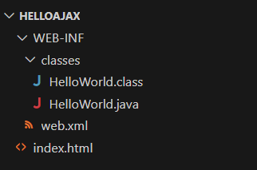

index.html:

<html>

<head>

<script>

function loadData() {

var xhttp = new XMLHttpRequest();

var n = document.getElementById("name").value;

xhttp.onreadystatechange = function() {

if (this.readyState == 4 && this.status == 200)

document.getElementById("content").innerHTML=this.responseText;};

xhttp.open("GET","hello?name="+n,true);

xhttp.send();

}

</script>

</head>

<body>

<h1 id="content">Iam Default Content</h1>

<input type="text" id="name"  oninput="loadData()">

</body>

</html>

HelloWorld.java

import java.io.*;

import javax.servlet.*;

import javax.servlet.http.*;

public class HelloWorld extends HttpServlet {

public void doGet(HttpServletRequest request, HttpServletResponse response)throws IOException, ServletException {

response.setContentType("text/html");

PrintWriter out = response.getWriter();

String n = request.getParameter("name");

out.println("<h4>" + n + " </h4>");

out.close();

}

}

**web.xml:**

<web-app>

<servlet>

<servlet-name>HelloWorld</servlet-name>

<servlet-class>HelloWorld</servlet-class>

</servlet>

<servlet-mapping>

<servlet-name>HelloWorld</servlet-name>

<url-pattern>/hello</url-pattern>

</servlet-mapping>

<welcome-file-list>

<welcome-file>index.html</welcome-file>

</welcome-file-list>

</web-app>

**Output:**

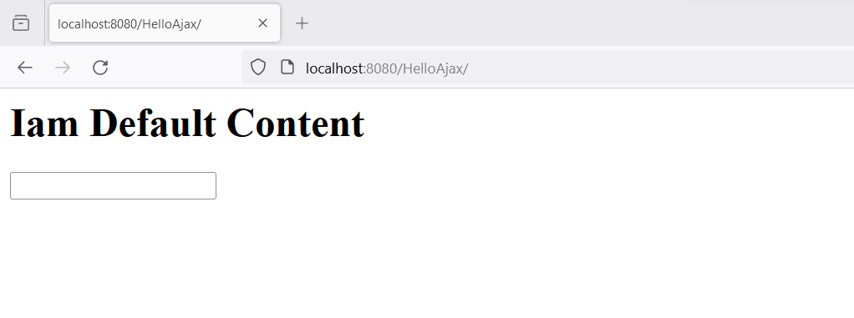 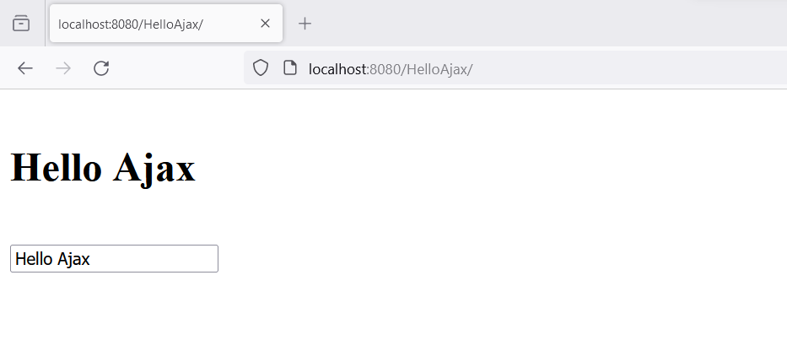

**Best Practices to be followed:**

1. Design before coding

2. Incremental coding

3. Usage of proper naming convention

4. Usage of Comments to the code

5. Indentation of code